Susan Schwartzman Public Relations susan@susanschwartzmanpublicity.com
www.susanschwartzmanpublicity.com
88 Kings Way, Pawling, NY 12564 845-493-0559
A GOTHIC NOVEL REMINISCENT OF
THE HAUNTING OF HILL HOUSE & JANE EYRE
A DARKER SHADE
By Laura Curtis
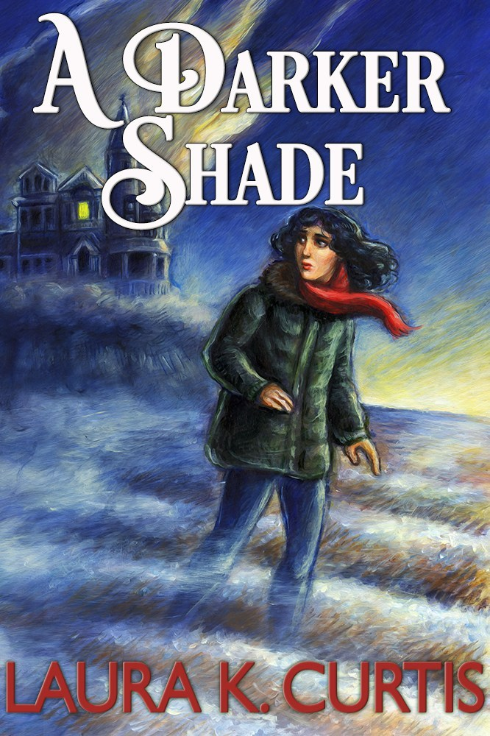

Is a ghost haunting Rook’s Rest, the forbidding, formidable mansion owned by the well-to-do Nathaniel Prescott?
Molly Allworth, who has been in service since leaving college when her mother died, has been offered a position that sounds too good to be true. When she is driven up the winding road to the remote Rook’s Rest in Maine, she knows something is wrong as soon as she enters the eerie mansion. “For a moment, fear knifed through me and I wanted to run,” she says. But this is the job of a lifetime.
She meets Liza Prescott, the little girl she was hired to care for, and who hasn’t spoken since swearing to have seen her mother’s ghost. Her father thinks that any belief in the supernatural is absurd. Molly meets the rest of the Prescott family, including Liza’s cousin Hailey and her charming uncle Matt, who flirts unabashedly with Molly. Could he have romantic designs on Molly? And what about her handsome, quietly reserved employer?
As a close bond develops between Liza and Molly, darker forces seem to prevail. Is the ghost that Liza claims to see really her mother, as she believes, or is there a more evil spirit haunting the house intent on seeking revenge? Are the lives of Molly, Liza and Nathaniel in danger?
When deep dark secrets from the past are revealed and Molly discovers the true nature, identity and intentions of the ghost, she realizes that neither she, Liza or Nathaniel are safe from the spirit’s thirst for revenge for the injustice committed upon her by Nathaniel’s ancestors, who treated the Native Americans as less than human.
In a riveting plot reminiscent of Shirley Jackson’s The Haunting of Hill House and Charlotte Brontë’s Jane Eyre, Laura K. Curtis has woven a terrifying tale of gothic horror. But A DARKER SHADE is not just a ghost story. It is a story resonant with historical overtones of how an injustice committed in the past continues to haunt the present.

ABOUT LAURA CURTIS
Laura K. Curtis gave up a life writing dry academic papers for writing decidedly less dry genre fiction. A member of RNA, MWA, ITW, and HWA, she has trouble settling into one lane. While she is best known as a writer of romantic suspense, she has also written contemporary romance novels and short crime fiction. A DARKER SHADE is her seventh novel, her first gothic and her first suitable for YA as well as adult audiences. Laura lives in Mt. Kisco with her husband and a pack of wild Irish Terriers, which has taught her how easily love can coexist with the desire to kill.

